**Hands on 1**

**Spring Data JPA - Quick Example**

**OrmLearnApplication.java:**

**package com.cognizant.orm_learn;**

**import com.cognizant.orm_learn.model.Country;**

**import com.cognizant.orm_learn.service.CountryService;**

**import org.slf4j.Logger;**

**import org.slf4j.LoggerFactory;**

**import org.springframework.boot.SpringApplication;**

**import org.springframework.boot.autoconfigure.SpringBootApplication;**

**import org.springframework.context.ApplicationContext;**

**import java.util.List;**

**@SpringBootApplication**

**public class OrmLearnApplication {**

**private static final Logger LOGGER = LoggerFactory.getLogger(OrmLearnApplication.class);**

**private static CountryService countryService;**

**public static void main(String[] args) {**

**ApplicationContext context = SpringApplication.run(OrmLearnApplication.class, args);**

**countryService = context.getBean(CountryService.class);**

**testGetAllCountries();**

**}**

**private static void testGetAllCountries() {**

**LOGGER.info("Start");**

**List<Country> countries = countryService.getAllCountries();**

**LOGGER.debug("countries={}", countries);**

**LOGGER.info("End");**

**}**

**}**

**Country.java:**

**package com.cognizant.orm_learn.model;**

**import jakarta.persistence.Entity;**

**import jakarta.persistence.Id;**

**import jakarta.persistence.Column;**

**import jakarta.persistence.Table;**

**@Entity**

**@Table(name = "country")**

**public class Country {**

**@Id**

**@Column(name = "co_code")**

**private String code;**

**@Column(name = "co_name")**

**private String name;**

**public String getCode() {**

**return code;**

**}**

**public void setCode(String code) {**

**this.code = code;**

**}**

**public String getName() {**

**return name;**

**}**

**public void setName(String name) {**

**this.name = name;**

**}**

**@Override**

**public String toString() {**

**return "Country [code=" + code + ", name=" + name + "]";**

**}**

**}**

**CountryService.java:**

**package com.cognizant.orm_learn.service;**

**import com.cognizant.orm_learn.model.Country;**

**import com.cognizant.orm_learn.repository.CountryRepository;**

**import org.springframework.beans.factory.annotation.Autowired;**

**import org.springframework.stereotype.Service;**

**import jakarta.transaction.Transactional;**

**import java.util.List;**

**@Service**

**public class CountryService {**

**@Autowired**

**private CountryRepository countryRepository;**

**@Transactional**

**public List<Country> getAllCountries() {**

**return countryRepository.findAll();**

**}**

**}**

**CountryRepository.java:**

**package com.cognizant.orm_learn.repository;**

**import org.springframework.data.jpa.repository.JpaRepository;**

**import org.springframework.stereotype.Repository;**

**import com.cognizant.orm_learn.model.Country;**

**@Repository**

**public interface CountryRepository extends JpaRepository<Country, String> {**

**}**

**application.properties:**

spring.application.name=orm-learn

logging.level.org.springframework=info

logging.level.com.cognizant=debug

logging.level.org.hibernate.SQL=trace

logging.level.org.hibernate.type.descriptor.sql=trace

logging.pattern.console=%d{dd-MM-yy} %d{HH:mm:ss.SSS} %-20.20thread %5p %-25.25logger**{25}** %25M %4L %m%n

spring.datasource.driver-class-name=com.mysql.cj.jdbc.Driver

spring.datasource.url=jdbc:mysql://localhost:3307/ormlearn

spring.datasource.username=root

spring.datasource.password=root

spring.jpa.hibernate.ddl-auto=validate

spring.jpa.properties.hibernate.dialect=org.hibernate.dialect.MySQLDialect

**pom.xml:**

<?xml version="1.0" encoding="UTF-8"?>

<project xmlns="http://maven.apache.org/POM/4.0.0" xmlns:xsi="http://www.w3.org/2001/XMLSchema-instance"

xsi:schemaLocation="http://maven.apache.org/POM/4.0.0 https://maven.apache.org/xsd/maven-4.0.0.xsd">

<modelVersion>4.0.0</modelVersion>

<parent>

<groupId>org.springframework.boot</groupId>

<artifactId>spring-boot-starter-parent</artifactId>

<version>3.5.3</version>

<relativePath/> <!-- lookup parent from repository -->

</parent>

<groupId>com.cognizant</groupId>

<artifactId>orm-learn</artifactId>

<version>0.0.1-SNAPSHOT</version>

<name>orm-learn</name>

<description>Demo project for Spring Data JPA and Hibernate</description>

<url/>

<licenses>

<license/>

</licenses>

<developers>

<developer/>

</developers>

<scm>

<connection/>

<developerConnection/>

<tag/>

<url/>

</scm>

<properties>

<java.version>21</java.version>

</properties>

<dependencies>

<dependency>

<groupId>org.springframework.boot</groupId>

<artifactId>spring-boot-starter-data-jpa</artifactId>

</dependency>

<dependency>

<groupId>org.springframework.boot</groupId>

<artifactId>spring-boot-devtools</artifactId>

<scope>runtime</scope>

<optional>true</optional>

</dependency>

<dependency>

<groupId>com.mysql</groupId>

<artifactId>mysql-connector-j</artifactId>

<scope>runtime</scope>

</dependency>

<dependency>

<groupId>org.springframework.boot</groupId>

<artifactId>spring-boot-starter-test</artifactId>

<scope>test</scope>

</dependency>

</dependencies>

<build>

<plugins>

<plugin>

<groupId>org.springframework.boot</groupId>

<artifactId>spring-boot-maven-plugin</artifactId>

</plugin>

</plugins>

</build>

</project>

**Database:**

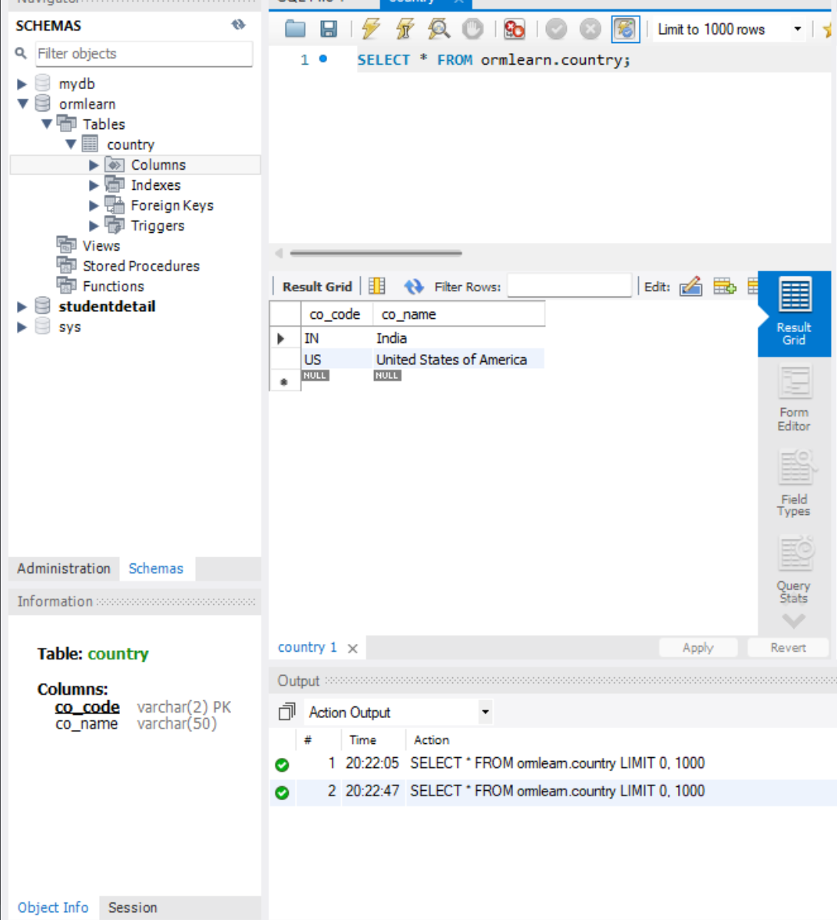

**OUTPUT:**

